LUKE 6:20a-23 (ESV) – 4 Blessings (“Beatitudes”)
(ideas to help memorize!)
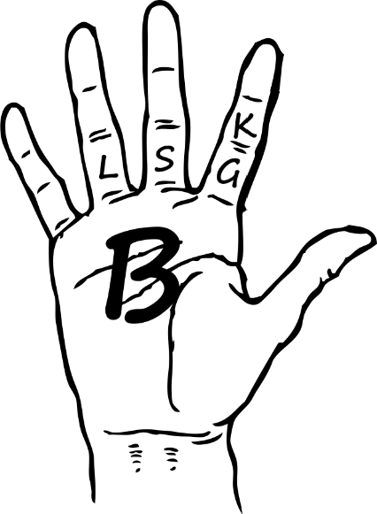
“BLESSED are you who are
- POOR,
- for yours is the KINGDOM of GOD.
“BLESSED are you who are
- HUNGRY now,
- for you shall be SATISFIED.
“Blessed are you who
- weep now,
- for you shall laugh.
“Blessed are you when people
- hate you and when they
- exclude you and
- revile you and
- spurn your name as evil,
- on account of the Son of Man!
“Rejoice in that day, and leap for joy,
1 2 3 4 5 6 7 8
for behold, your reward is great in heaven;
2nd part of 4th blessing

for so their fathers did to the prophets.”

