|  |  |  |  |  |  |  |
| --- | --- | --- | --- | --- | --- | --- |
|  | 1 | 2 | 3 | 4 | 5 | 6 |
| 7 | 8 | 9 | 10 | 11 | 12 | 13 |
| 14 | 15 | 16 | 17 | 18 | 19 | 20 |
| 21 | 22 | 23 | 24 | 25 | 26 | 27 |
| 28 | 29 | 30 | 31 |  |  |  |

JANUARY 2024

January 2024 Reading Plan

**Bethesda Church Office Information**

**Admin Hours: Tues-Fri, 9:30am-3:30pm**

**Phone: 204-987-2890**

**1350 Grant Ave., Winnipeg, MB R3M 2A7**

**Email:** [**office@bethesdachurch.ca**](mailto:office@bethesdachurch.ca)

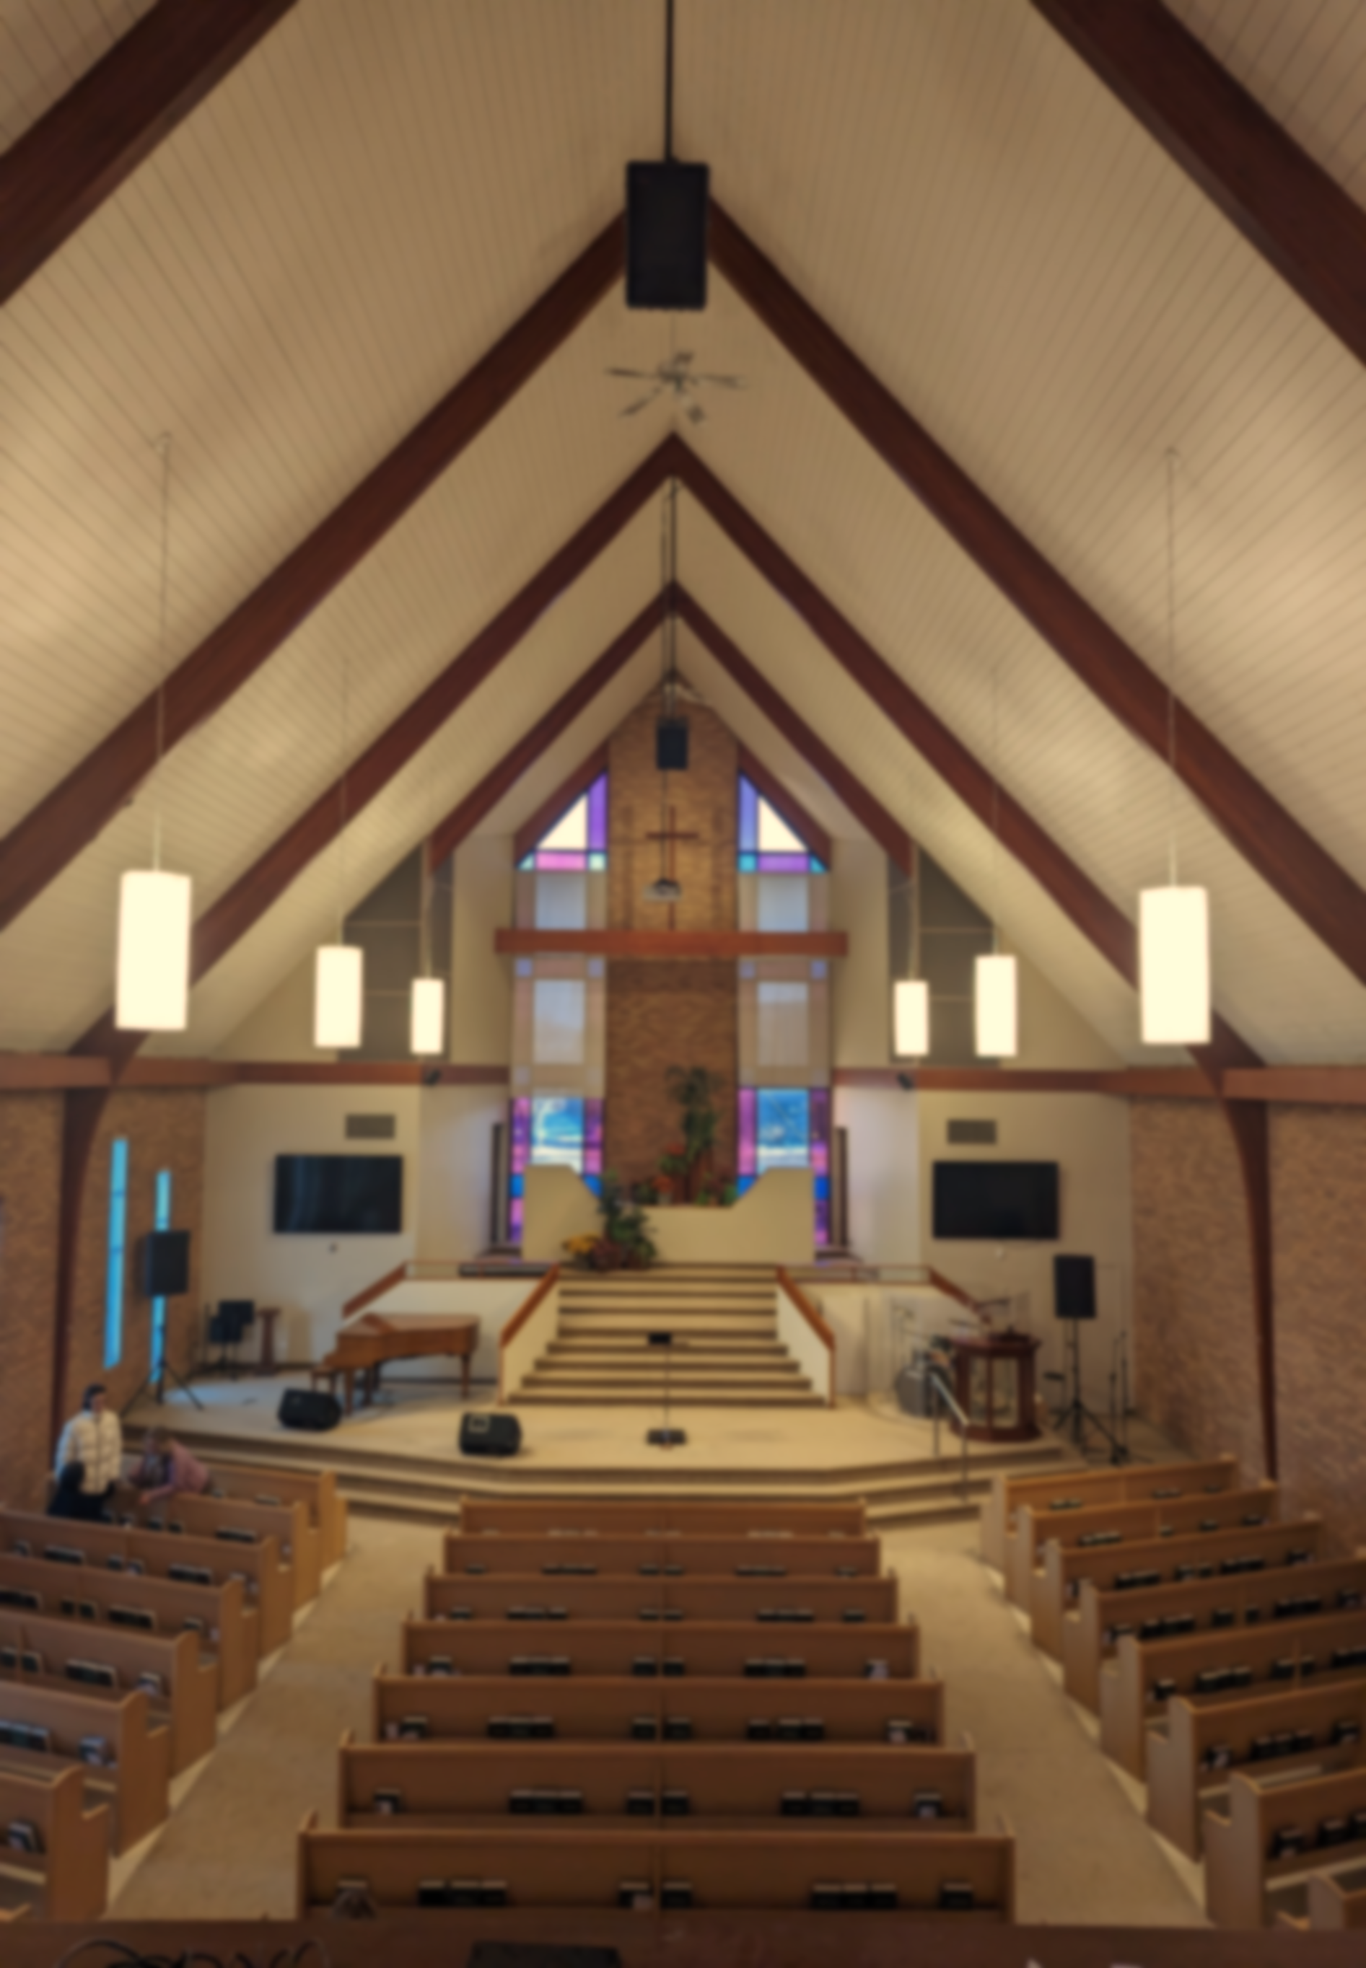

BethesdaChurch

**Newsletter**

 “1**Brothers**[and sisters]***, if anyone is caught in any transgression, you who are Spiritual should restore him in a spirit of gentleness. Keep watch over yourself, lest you too be tempted.*** 2**Bear one another’s burdens, and so fulfill the law of Christ.**3**For if anyone thinks he is something, when he is nothing, he deceives himself.** 4**But let each one test his own work, and then his reason to boast will be in himself alone and not in his neighbor.** 5**For each will have to bear his own load.**” – Galatians 6:1-5

**Congregational letter January 2024**

My Dear Bethesda Family & Friends; a good Friday afternoon to you and yours!  
   
I hope you and your loved ones are Spiritually strong and physically, emotionally, and mentally well. (We are experiencing among our members and leaders a bout with sickness, including another round of COVID, so I hope you can avoid the various bugs flying around us and stay well. But if you feel sick, please stay home, and take advantage of our livestream options on Sundays and Wednesdays.)  
   
As I get started, I wanted to let you know I’m feeling conflicted, today. But don’t misunderstand me: When I say, “I’m feeling ‘**conflicted**,’” I’m simply acknowledging that I have mixed emotions about life, health, relationships, ministry, and even the future. I’ll be okay; I’m just ... **conflicted**!

When life, health, relationships, ministry, and future are in flux, when the future is more uncertain than usual – understanding we never really know the future, ‘**conflicted**’ or ‘mixed’ is a perfectly honest, emotional, and rational

response to varied stimuli. (Sorry, I just slipped into social science mode!)

But I’m also feeling **grateful**, today. The Lord Jesus Christ has given me a wonderful wife, delightful

kids, and a family of origin who love and support each other. This June (the 4th, 2024, to be exact), Shelly and I will have been married for ... 30 years! We can hardly believe it! Or, at least, I can hardly believe it; it may seem like 50+ years to Shelly! But to be fair, we’ve covered a lot of ground in these years, together! We’ve been blessed with two truly lovely daughters, Abby (26) & Ashleigh (almost 23), and I’m certainly grateful for my son Christopher (almost 39). The Lord Jesus has also given us – you and me, I mean – 16+ years (so far) to get to know each other, to learn to love and trust each other, to do some good things together, and maybe some of those things have been of lasting, even eternal value. I could and I probably should name several very special, truly indispensable friendships and partnerships the Lord Jesus has blessed us with at Bethesda too, but I’ll save that for another occasion. In any case, I’m feeling **grateful** today

I’m also feeling **hopeful**. As I look into our short-to-near-term future as a Congregation, so far as I can see and tell, I see great possibilities ahead – that is, if we steward them well, carefully, and with true Biblical and Spiritual discernment. By ‘them,’ I mean the possibilities of/in our truly Biblical-Christian faith, our Spirit-born lives, our Spirit-infused relationships, our Spirit-gifted roles, paying special attention to what I preached about last week and Pastor Yuri will continue to preach about

But I’m also feeling **grateful**, today. The Lord Jesus Christ has given me a wonderful wife, delightful

this Sunday – that which accrues “**For God’s Glory & the Good of God’s (All?) People**.” This does and will require that we attend especially to those aspects of our Biblical-Christian lives and ministries that produce Spiritual fruit and spread God’s love, grace, mercy, forgiveness, joy, and peace. I truly am **hopeful**!  
   
I’m even **expectant**! Now, some of you might immediately respond, “Wait a minute! Aren’t ‘**hopeful**’ and ‘**expectant**’ the same thing?” Well, yes ... and no. They’re definitely related to each other, but this is the distinction I’m making: **Hopeful** seems to me to be at the same time less focused, less distinct, more general, more distant, and more wishy. **Expectant**, on the other hand, seems to me to be clearer, closer, more substantial, and I am **expectant** that the Lord Jesus Christ has some very good, even great things in store for us in the near-to-edian future, based on the evidence I can see right in front of me, today: 1- a renewed interest in personal Bible study and dependence on God in prayer are growing; 2- several new members are on their way (class, Sat., Nov. 18th!); 3- at least one baptism of a believer is upcoming later this month (Sun., Nov. 26th!); 4- new, multigenerational people are attending our Sunday worship gatherings every week and many are coming back in subsequent weeks; 5- one Afghan refugee family arrived (and is funded) and another is anticipated (and is funded), soon; 6- Jesus’s own provision in worship, teaching, and leading ministries sufficient to meet our current needs are in place; 7- I’m transitioning out-of and Pastor Yuri is transitioning in-to the senior pastor role. (On January 1st, he becomes ‘senior pastor-designate,’ and I become, in effect, associate pastor. All these things are happening right now and every week!) So, yes, I’m **expectant** for more and better!  
   
Speaking of new members and baptisms, I invite you to talk to me about either, or both!  
   
 Our next “**New** **Member** **and** **Information** **Class**” will be next Saturday, November 18th, 10am-2:30pm, in the Bethesda Lower Lounge (meeting room downstairs, off the Fellowship Hall). Please note: This class is not only for those pursuing formal membership at Bethesda; it’s also a resource for anyone who’d like to learn more about who we are, what we’re about, how we’re structured, and where we’re going! **JOIN US!**  
   On Sunday, November 26th, we’ll offer an opportunity for **baptisms** as part of our regular, weekly Worship Gathering all who’ve been bought by the blood of Christ and reborn by the Spirit of God – that is, for any and all born-again believers in Jesus Christ. If you’d like to be a part of this exciting event, please come talk to me, and soon! I’d love to hear from you and include you, if possible!  
 […]

Grace to you and yours, thanks, love, **JOY!** & peace!  
   
Pastor MarkANNOUNCEMENTS

* **PLEASE KEEP PRAYING FOR E, S & THEIR FIVE CHILDREN!**

We’ve gotten an exciting update; they may be here ... sooner! Let’s pray for their protection and God’s provision all the way to Canada. Items STILL NEEDED for E&S: 1 queen mattress protector, 1 set twin sheets, 4 standard pillow cases & 2 comforters or bedspreads (for boys)!

* **INFORMAL BBYOL FELLOWSHIP!**

Bethesda Bring Your Own Lunch provides opportunities for   
fellowship, downstairs in the Fellowship Hall, after every service.  
 Join us as you can to build our Bethesda fellowship!

* **“PERSPECTIVES” COURSE: WEEKLY, STARTING SEPTEMBER 5**

[…] The next course will be hybrid (Zoom and in-person), starting this Tuesday for 14 weeks, 6:00-8:30pm. Course fee: $395 includes textbooks and Scholarships are available. Please see Patti Poirier for more information.

* **TEACHING OR HELPING WITH CONVERSATIONAL ENGLISH CLASS?**

As our fall programing approaches, we are considering restarting our very fruitful English Conversation class, probably on Wednesday evenings, 6:30-8pm. If you might be interested, either to take our class yourself, teach, or support, please contact Neil Craton.

* **UPCOMING 2023 BETHESDA CHURCH ANNUAL MEETING**

Our Annual Meeting date and time have been set. We will meet on Wednesday evening, October 25th @ 7pm in the Bethesda Fellowship Hall.

* **Join us on September 17th for “Welcome Back, Bethesda” Sunday!**

Kids Church for children ages 3-12 will resume that day. Following the worship service, we’ll gather for a fellowship meal. Please sign up to bring any kind of salad – green salad, pasta salad, bean salad, potato salad, fruit salad, or your own special salad. We’ll also enjoy hotdogs and ice cream. Fun games with prizes will ensue! We look forward to seeing you there!**Prayer and Intercession**

Please join us in prayer for **Dave & Shanlee Birrell**, our Gospel partners with **Intervarsity-Canada**.

**Pray with us for the unwell among us –** in hospital (H), care home (CH), or just having an especially difficult time:

*Our Afghan Refugee Families (Q&E)

*Mona Behrens

* Gail Barnes

*Lawrence & Selma Churchill

*Anshula Donalld (high pressure inside brain, pray for her husband)

*Venus Coté (our NECM missionary)

*Edwin & Kamala Henry (Esther’s Dad & Mom) healing from surgery and rest

*Ron De Hoff (Patti’s brother)

*Andrew Friesen (our AIM missionary)

*Bernice Gruenke (health & diagnosis)

*Marion Hill (Susanne’s Mom)/Susanne

*Homaira & Sejed

*Mujeeb (Homaira’s brother)

*Mujeeb/Homaira’s parents (in Pak.)

*George Manalang

*Joan McRae (Misericordia Place)

*Michael (Eunice’s neighbor)

*Laylee Moterrased

*Andrew Poirier (blood clots; housing)

*Patti Poirier (health and strength)

*Russian People & Church

*Sean Smith (Evelyn’s son)